Kimberly Orozco
June 10, 2025
Module 2.2
Documented Debugging + Flowchart
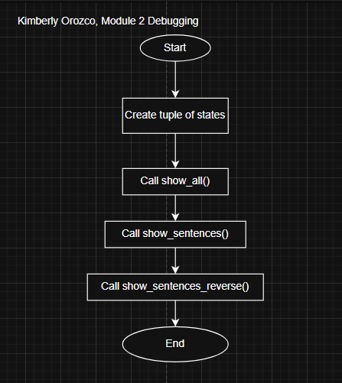
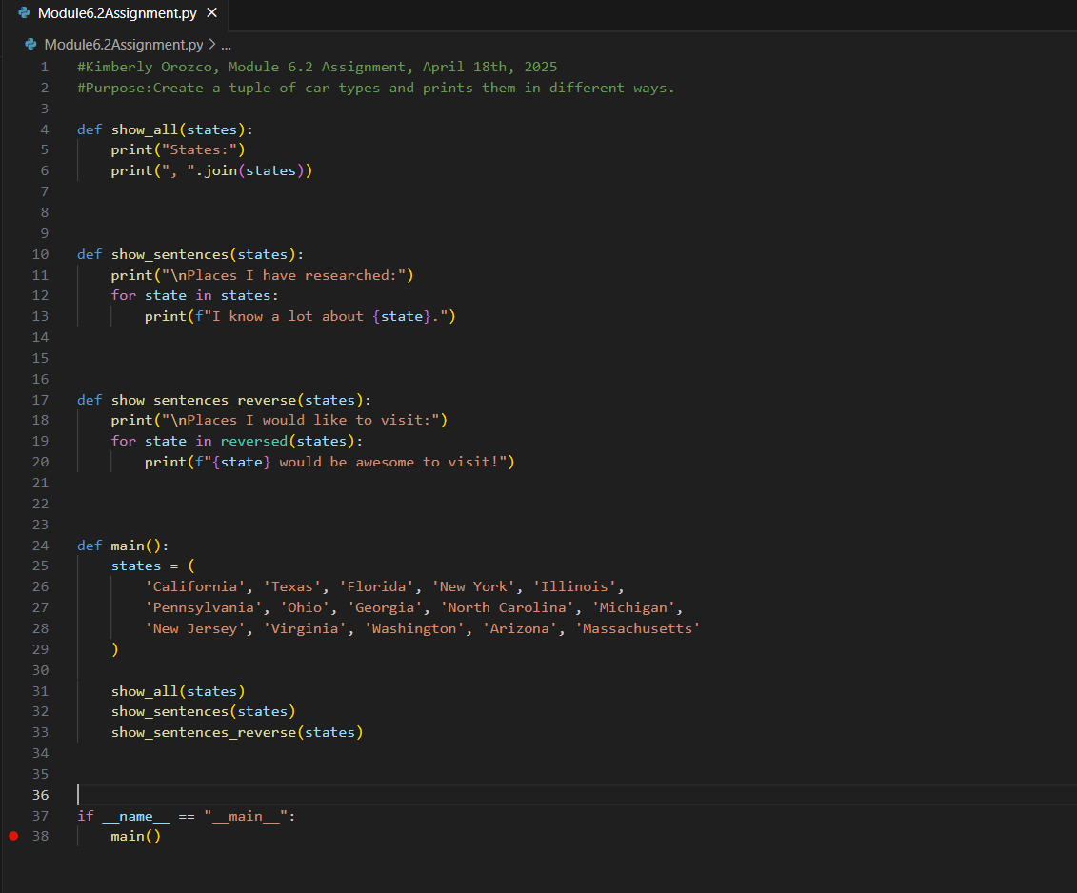
Breakpoint at main()
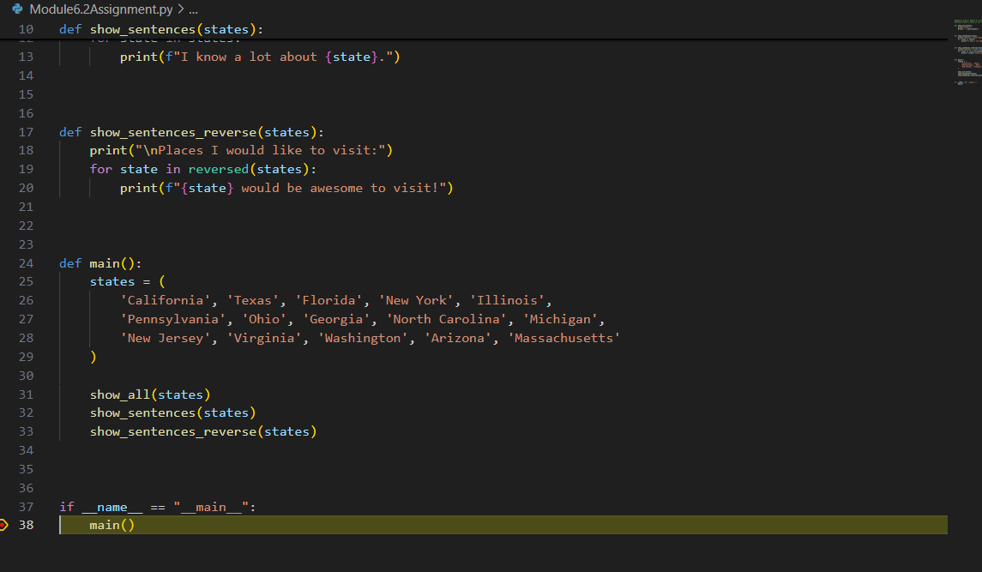
When I click step into this is where it went
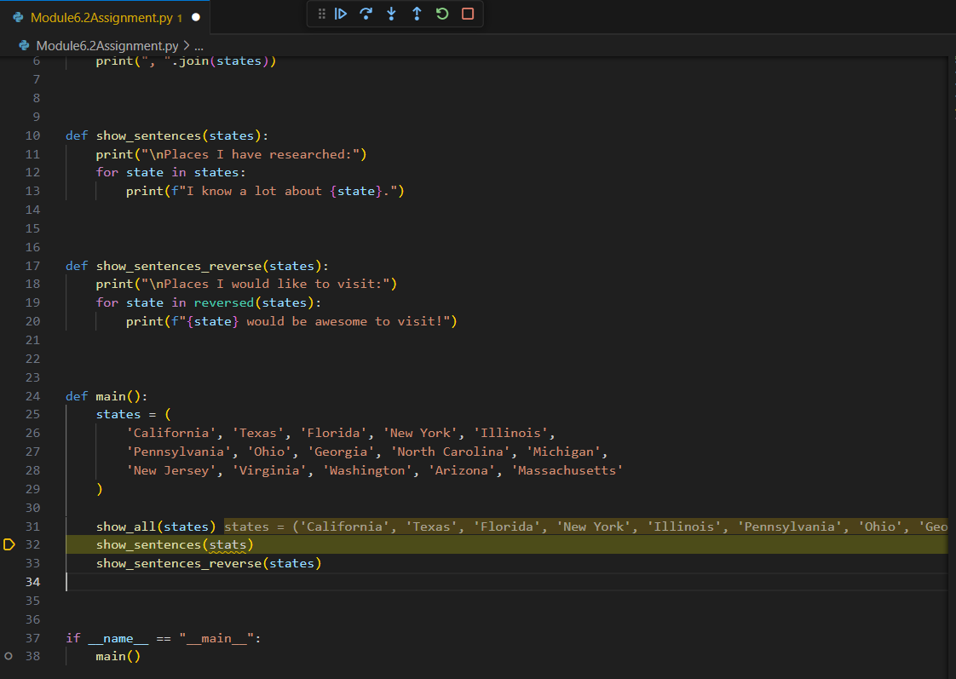
I misspelled states.

